

## FACULTY OF ENGINEERING AND TECHNOLOGYBACHELOR OF TECHNOLOGY

**ARTIFICIAL INTELLIGENCE LABORATORY (203124308)**

## 5RD SEMESTER COMPUTER SCIENCE & ENGINEERING DEPARTMENT

LAB MANUAL

|  |
| --- |
| **CERTIFICATE**  This is to certify that  Mr. **NIRBHAY GANESH SIRSIKAR** with enrollment no. **200303124033** has successfully completed his laboratory experiments in **Artificial Intelligence Laboratory (203124308)** the B.Tech. 3nd year from the department of **Computer science and Engineering (Artificial Intelligence)** during the academic year **2022-23.**    Date of Submission: ......................... Staff In- charge: ...........................  Head Of Department: ........................................... |
|  |

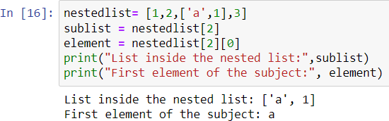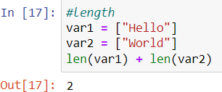

# PRACTICAL – 1

## **Aim:** Write a python program to implement list operation

(Nested List, Length Concatenation, Membership, Iteration, Indexing & Slicing) :

**Nested List:**

nestedlist= [1,2,['a',1],3] sublist = nestedlist[2] element = nestedlist[2][0]

print("List inside the nested list:",sublist) print("First element of the subject:", element)

**Output:**

**Length Concatenation:**

var1 = ["Hello"] var2 = ["World"] len(var1) + len(var2)

**Output:**

**Membership Operator: IN OPERATOR:**

x = ["Vadodara", "Amreli", ] print("Vadodara" in x) print("Surat" not in x)

**NOT-IN OPERATOR:**

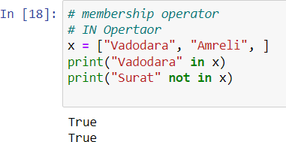

**Output:**

x = ["Vadodara", "Amreli", ] print("Vadodara" in x) print("Surat" not in x)

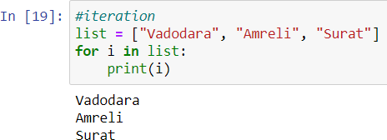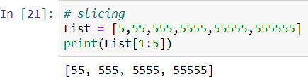

**Iteration:**

list = ["Vadodara", "Amreli", "Surat"] for i in list:

print(i)

**Output:**

**Slicing:**

List = [5,55,555,5555,55555,555555]

print(List[1:5])

**Output:**

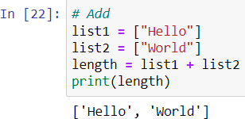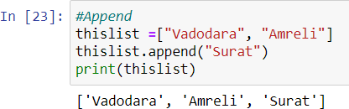

# PRACTICAL – 2

## **Aim:** Write a python program to implement list methods ( Add, Append, Extend, Delete ) :

### ADD:

list1 = ["Hello"] list2 = ["World"] length = list1 + list2 print(length)

**Output:**

### Append:

thislist =["Vadodara", "Amreli"] thislist.append("Surat") print(thislist)

**Output:**

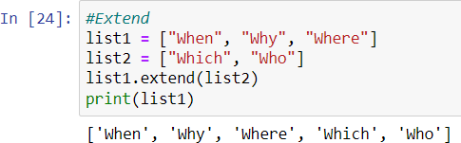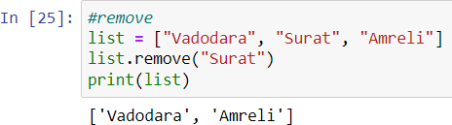

### Extend:

list1 = ["When", "Why", "Where"] list2 = ["Which", "Who"] list1.extend(list2)

print(list1)

**Output:**

### Remove:

list = ["Vadodara", "Surat", "Amreli"] list.remove("Surat")

print(list)

**Output:**



# PRACTICAL – 3

## **Aim:** Write a python program to implement simple Calculator:

### Source Code:

def add(x,y): return x+y def sub(x,y): return x-y

def div(x,y): return x/y def mul(x,y): return x*y

print("Please select any operator:\n 1. Addition\n 2. Substraction\n 3.

Multiplication\n 4. Division\n")

operator = int(input("Enter Operation: \nIn terms of (1,2,3,4) : ")) input1 = int(input("Enter First number : "))

input2 = int(input("Enter Second Number : "))

if operator==1:

print(input1," + ",input2," = ",add(input1,input2)) elif operator==2:

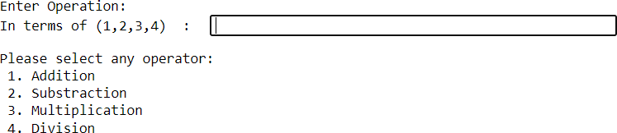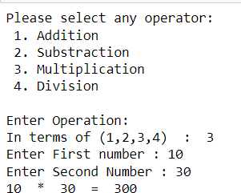

print(input1," - ",input2," - ",sub(input1,input2)) elif operator==3:

print(input1," * ",input2," = ",mul(input1,input2)) elif operator==4:

print(input1," / ",input2," = ",div(input1,input2)) else:

print("Wrong Operator")

**Output:**

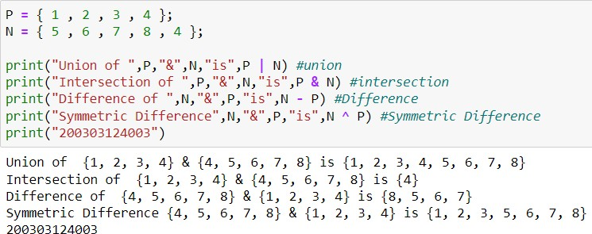

# PRACTICAL – 4

## **Aim:** Write a python program to implement different Set Operation (Union, Difference, Intersection, Symmetric):

### Source Code:

P = { 1 , 2 , 3 , 4 };

N = { 5 , 6 , 7 , 8 , 4 };

print("Union of ",P,"&",N,"is",P | N) #union print("Intersection of ",P,"&",N,"is",P & N) #intersection print("Difference of ",N,"&",P,"is",N - P) #Difference

print("Symmetric Difference",N,"&",P,"is",N ^ P) #Symmetric Difference

**Output:**

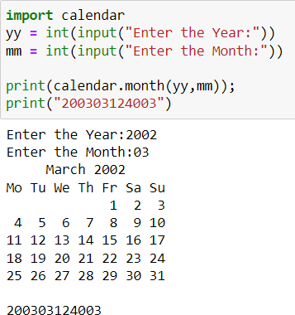

# PRACTICAL – 5

## **Aim:** Write a python program to implement different Set Operation (Union, Difference, Intersection, Symmetric):

### Source Code:

import calendar

yy = int(input("Enter the Year:")) mm = int(input("Enter the Month:")) print(calendar.month(yy,mm));

**Output:**

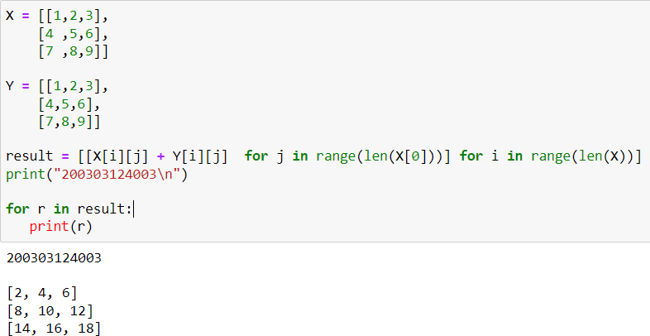

# PRACTICAL – 6

## **Aim:** Write a python program to add two matrices:

### Source Code:

X = [ [1, 2, 3],

[4, 5, 6],

[7, 8, 9] ]

X = [ [1, 2, 3],

[4, 5, 6],

[7, 8, 9] ]

result = [[X[i][j] + Y[i][j] for j in range(len(X[0]))] for i in range(len(X))] for r in result:

print(r)

**Output:**

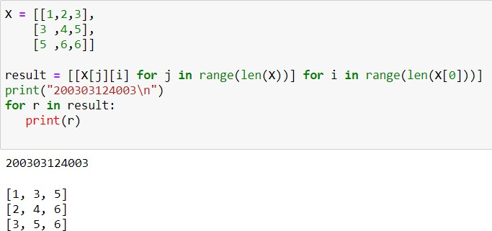

# PRACTICAL – 7

## **Aim:** Write a python program to transpose two matrices:

### Source Code:

X = [ [1, 2, 3],

[3, 4, 5],

[5, 6, 6]]

result = [[X[j][i] for j in range(len(X))] for i in range(len(X[0]))] for r in result:

print(r)

**Output: **